**Level 1**

**Bug #1**

**Summary:** Text in notification field is not centered to header on main page

**Priority:** P3

**Severity:** S3

**Steps:**

1. Open site <https://odessa.oxford-med.com.ua/>
2. Pay attention on notification field

**Expected result:** Text is centered in notification field to header

**Actual result:** Text in notification field is not centered to header

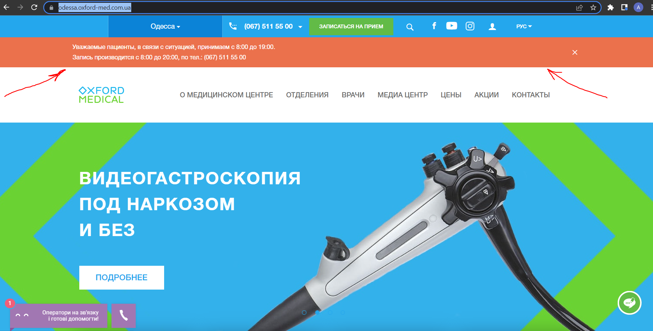

**Environment:** Google Chrome, Microsoft Edge, Internet Explorer

**Bug #2**

**Summary:** Two different languages used in city names menu when click on special city name

**Priority:** P3

**Severity:** S4

**Steps:**

1. Open site <https://lviv.oxford-med.com.ua/>
2. Click on city name at top left side on website
3. Pay attention on city names menu

**Expected result:** All city names are using single language

**Actual result:** Two different languages used in city names menu

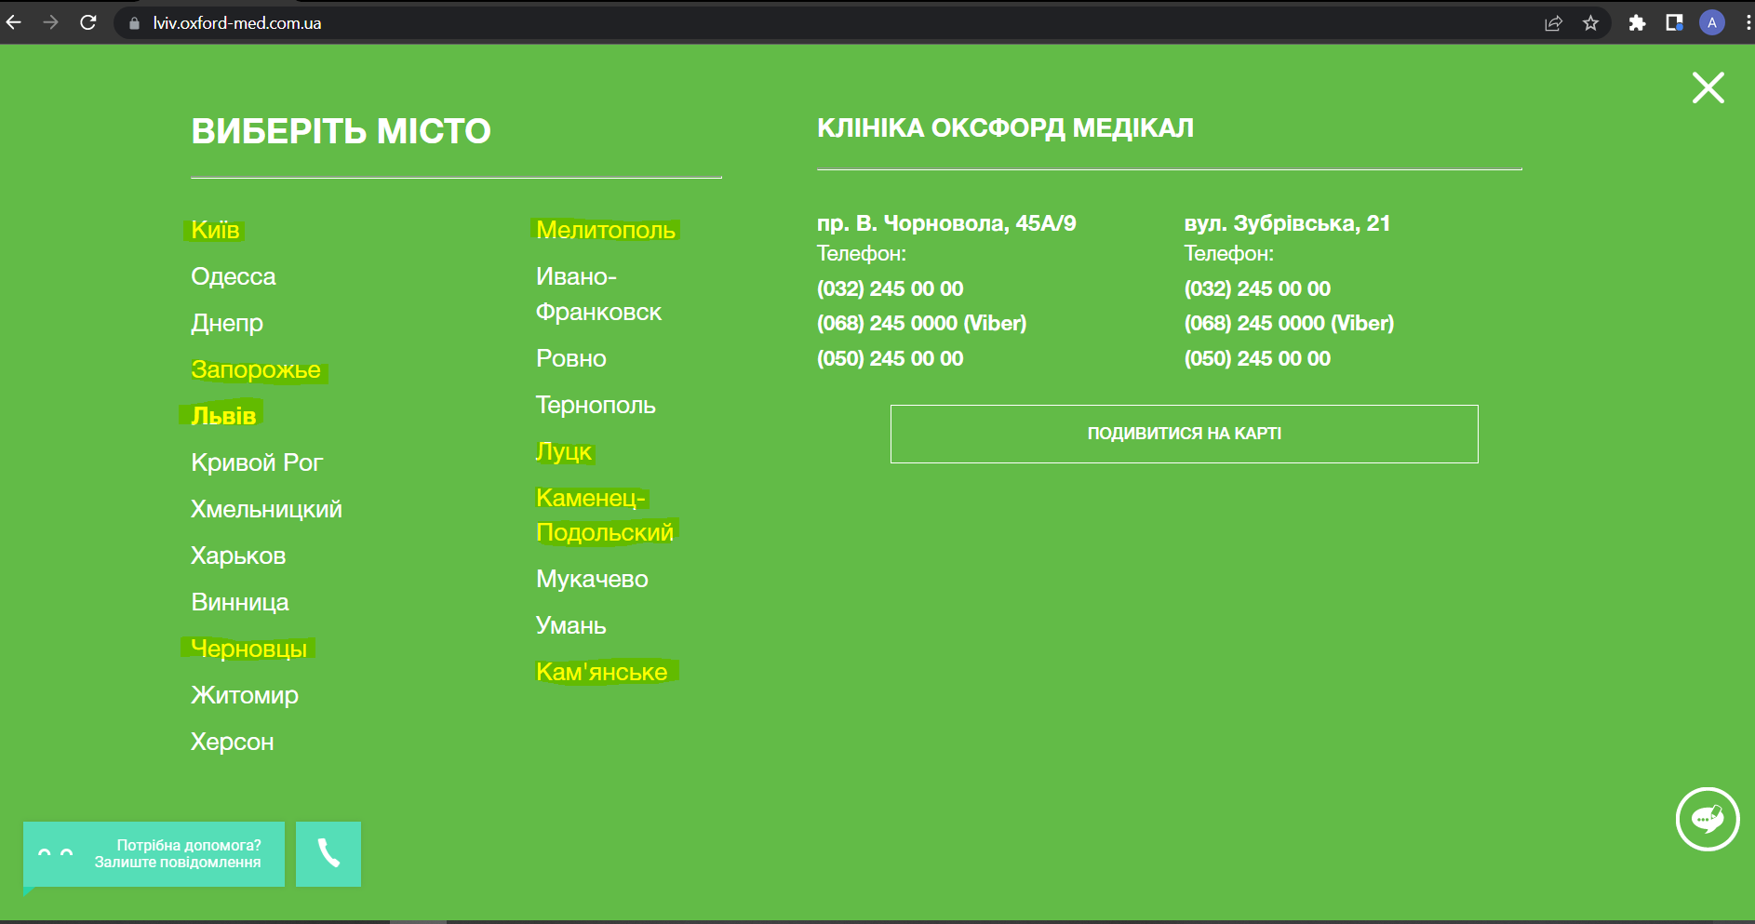

**Environment:** Google Chrome, Microsoft Edge, Internet Explorer

**Bug #3**

**Summary:** English language option is missing in language dropdown menu after choosing special city name

**Priority:** P3

**Severity:** S3

**Steps:**

1. Open site <https://oxford-med.com.ua/>
2. Click on language dropdown button on top right side of website
3. Check that “ENG” language is available
4. Click on city name at top left side on website
5. Choose “Львов” city name from menu
6. Click on language dropdown button again
7. Pay attention that option “ENG” is missing in the list

**Expected result:** English language option is available for all available cities

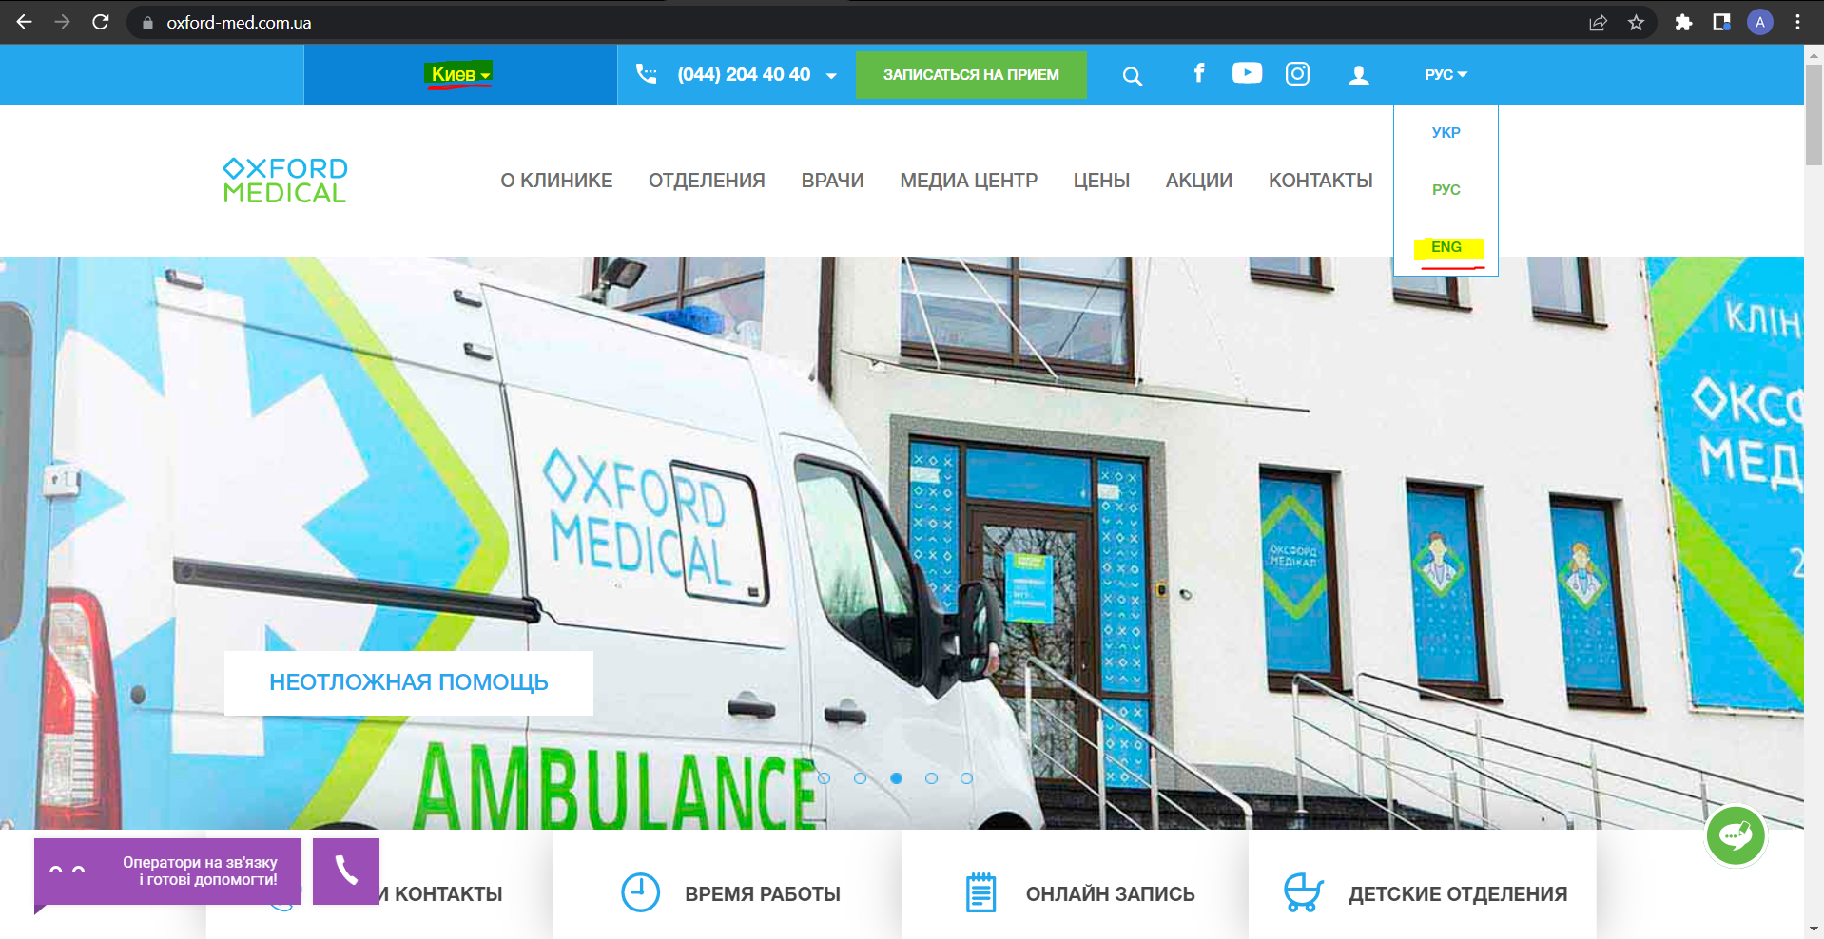

**Actual result:** English language option is missing in language dropdown menu after choosing special city name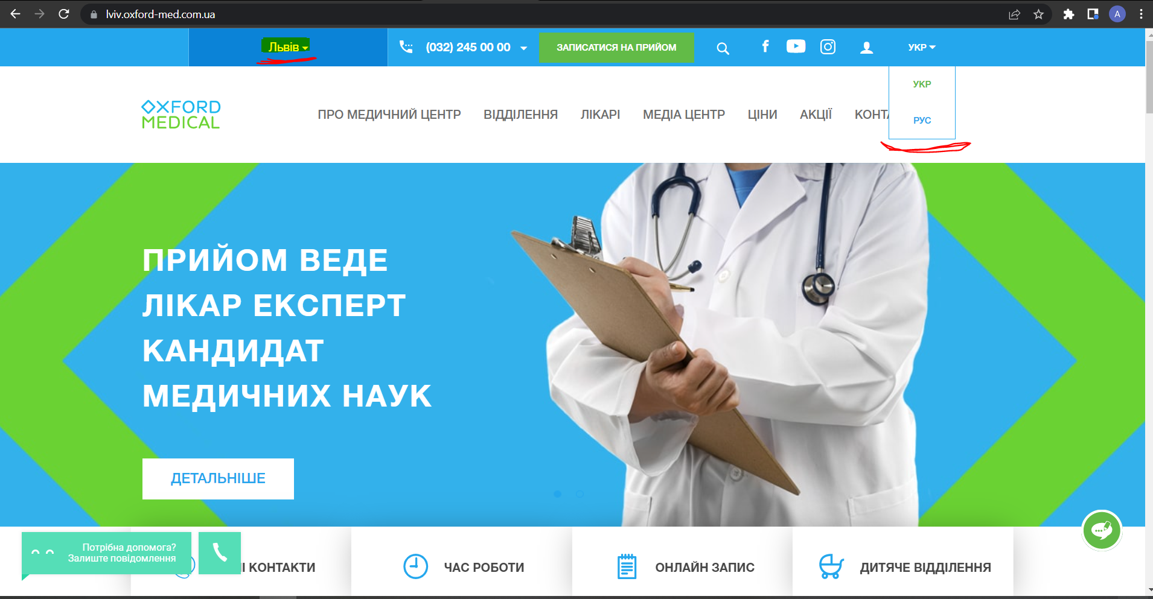

**Environment:** Google Chrome, Microsoft Edge, Internet Explorer

**Bug #4**

**Summary:** Support window field is not translated to language as per chosen on website

**Priority:** P3

**Severity:** S4

**Steps:**

1. Open site <https://oxford-med.com.ua/en/>
2. Pay attention on support window field at down-left side of website

**Expected result:** Support window field use the same language as chosen on website

**Actual result:** Support window field is not translated to language as per chosen on website

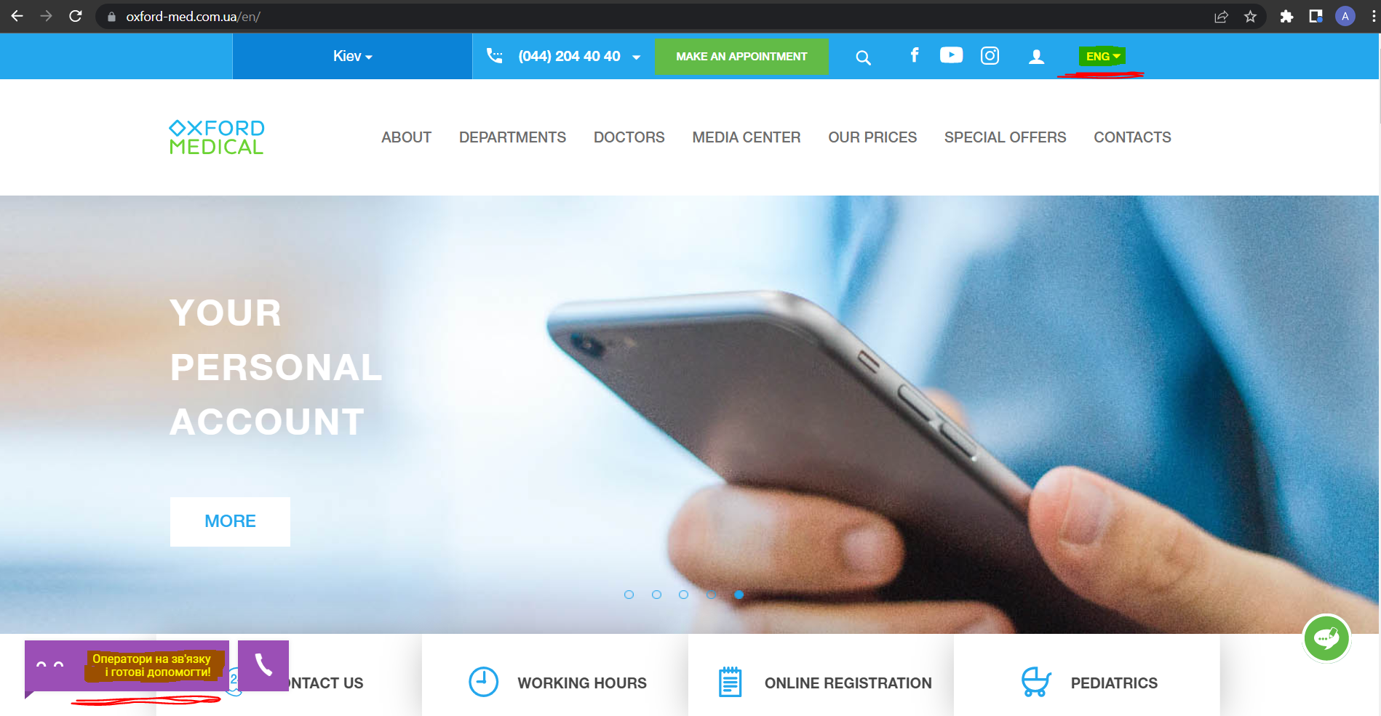

**Environment:** Google Chrome, Microsoft Edge, Internet Explorer

**Bug #5**

**Summary:** Placeholder language is not changing as per chosen at website in search field when click on search icon button

**Priority:** P3

**Severity:** S4

**Steps:**

1. Open site <https://oxford-med.com.ua/ua/>
2. Click on Search button (magnifying glass icon) at the top of website
3. Pay attention on placeholder language in the field
4. Change language to “ENG” in language dropdown menu at the main page
5. Repeat steps 2-3

**Expected result:** Placeholder language is the same as per chosen at website in search field

**Actual result:** Placeholder language is not changing as per chosen at website in search field

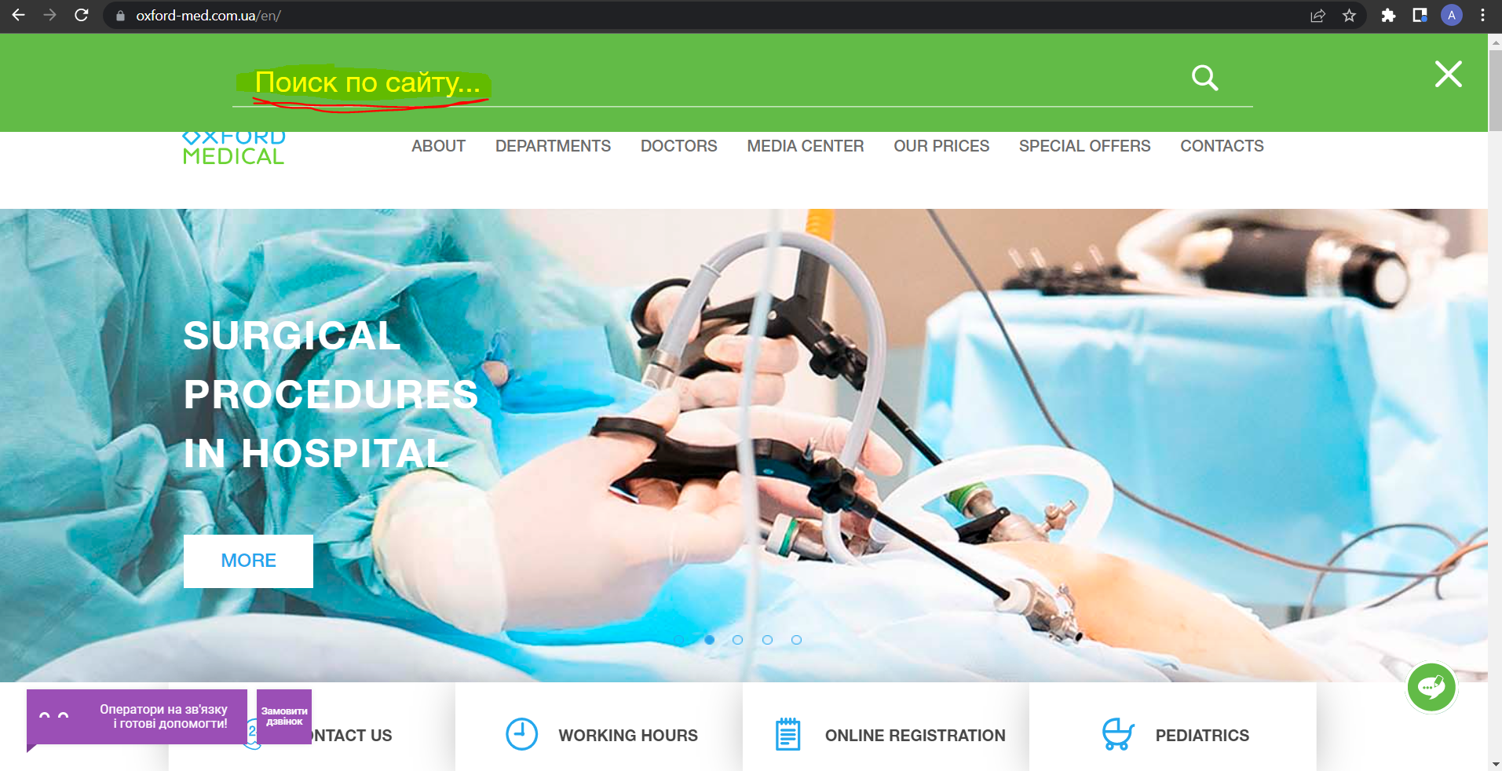

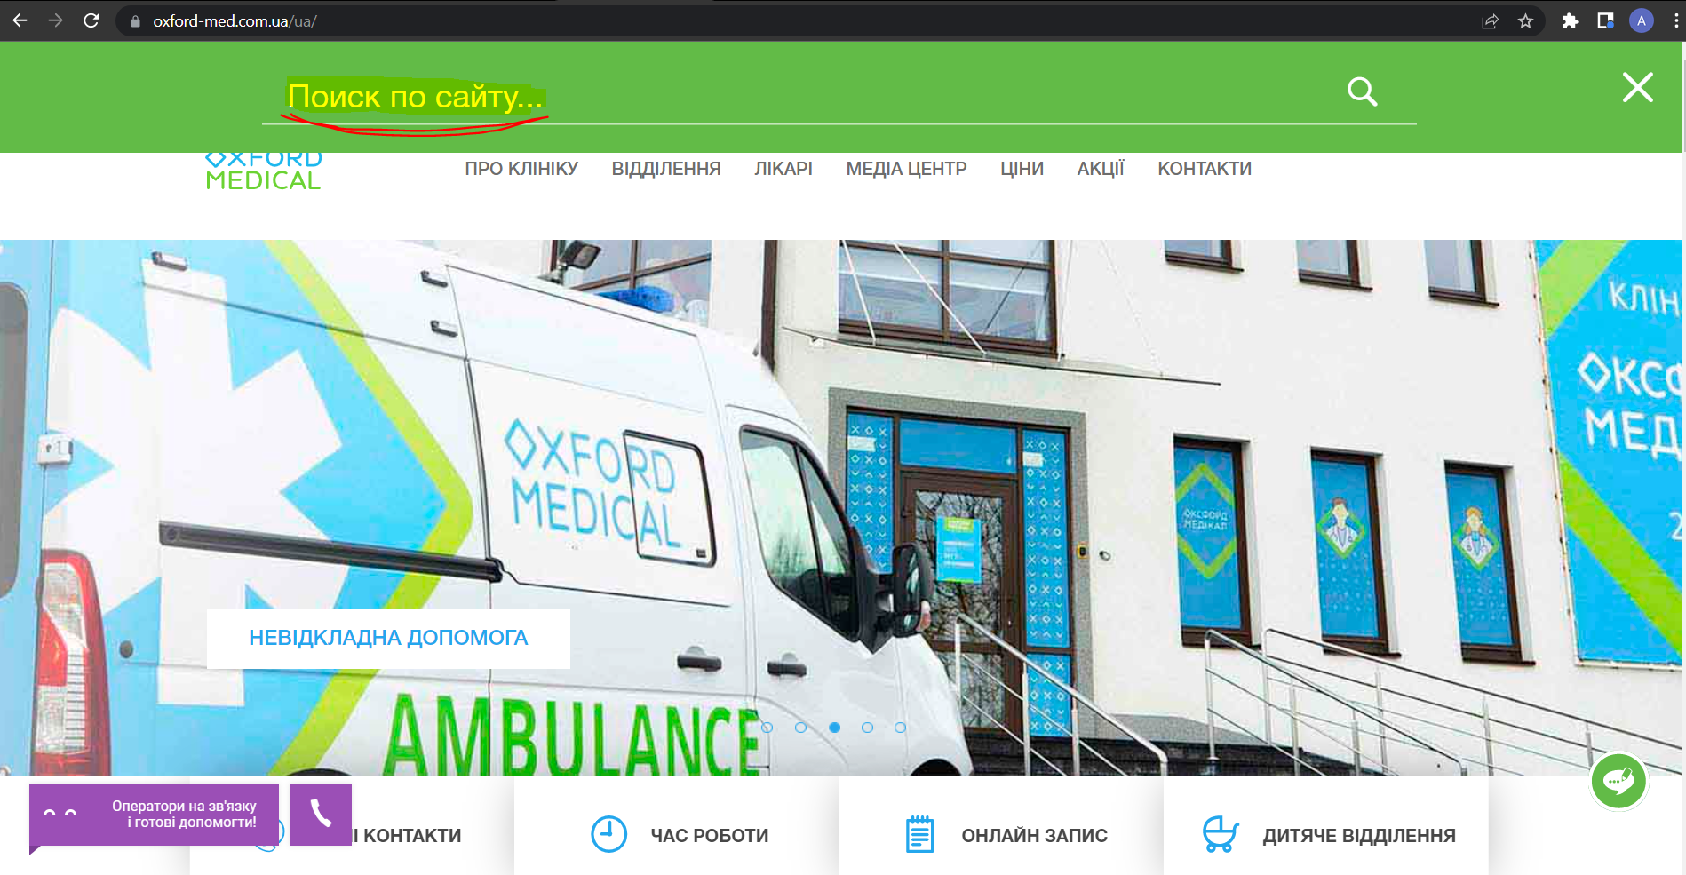

**Environment:** Google Chrome, Microsoft Edge, Internet Explorer

**Level 2**

Cross browser testing:

| Bug/Browser name | **Google Chrome** | **Mozila Firefox** | **IE** |
| --- | --- | --- | --- |
| Bug #1 | Base testing | * different language of interface | * different scale * bold text in notification field |
| Bug #2 | Base testing | No differences | * different scale |
| Bug #3 | Base testing | * different language of interface | * different scale |
| Bug #4 | Base testing | No differences | * different scale * support window button is missing |
| Bug #5 | Base testing | * different color of placeholder text | * different scale * placeholder is missing in search field |

**Level 3**

**Визначити шрифт, його розмір, колір та колір бекграунду**

* ***номер телефону у хедері***
* шрифт: HelveticaNeue-Bold, sans-serif
* розмір: 16px/24px
* колір: #fff
* колір бекграунду: #24a7ed
* ***ім’я асистента при виклику чата допомоги***
* шрифт: Roboto, sans-serif
* розмір: 11px
* колір: #ccc
* колір бекграунду: #fff
* ***кнопка “інші міста” у футері сайту***
* шрифт: HelveticaNeue, sans-serif
* розмір: 14px/24px
* колір: #24a7ed
* колір бекграунду: #ccc
* ***Placeholder “ім’я” у формі “ЗАПИСАТИСЯ НА ПРИЙОМ”***
* шрифт: HelveticaNeue, sans-serif
* розмір: 14px/14px
* колір: #535353
* колір бекграунду: #fff